**CLIPPERS**

**LAB # 05**



**Spring 2023**

**CSE-206L Electronic Circuits Lab**

Submitted by: **Ali Asghar**

Registration No.: **21PWCSE2059**

Class Section: **C**

“On my honor, as student of University of Engineering and Technology, I have neither given nor received unauthorized assistance on this academic work.”

Submitted to:

**Engr. Abdullah Hamid**

**Date**: 7th July 2023

**Department of Computer Systems Engineering**

**University of Engineering and Technology, Peshawar**

**OBJECTIVES:**

* To calculate and measure the output voltages of Parallel & Series clipper circuits.

**EQUIPMENT:**

* Oscilloscope
* Function Generator
* Digital Multimeter (DMM)
* DC power supply

**COMPONENTS:**

* Diode: Silicon (D1N4002)
* Resistors: 2.2kΩ, 3.3kΩ

**Diode:**

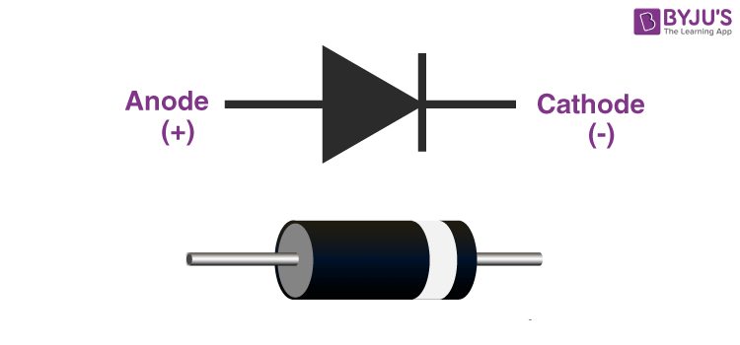A diode is a fundamental electronic component with two terminals that allows current to flow primarily in one direction. It exhibits low resistance (forward bias) when current flows from the anode to the cathode, and high resistance (reverse bias) when current attempts to flow in the opposite direction.

Figure 1-1: Typical Diode

**Clipper:**

A clipper is a circuit designed to limit the output voltage of a circuit to a predetermined level without significantly distorting the remaining portion of the applied waveform. Clipper circuits typically consist of linear elements such as resistors and non-linear elements like diodes or transistors, but they do not incorporate energy-storage elements like capacitors. The purpose of clipping circuits is to select a specific part of a signal waveform that lies above or below a certain reference voltage level for transmission or processing.

Clipper circuits can remove certain portions of an arbitrary waveform near its positive or negative peaks, and this can be achieved at either one level or two levels. As a result of clipping, there is a noticeable alteration in the waveform's shape within the clipped section.

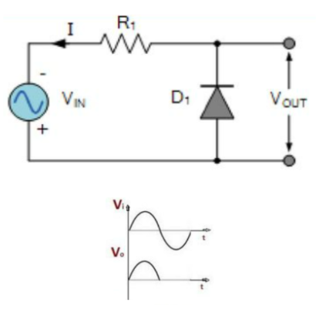

Figure 1-2: Simple Clipping Circuit Using Diode

There are two main types of clippers: positive clippers and negative clippers.

**Positive Clippers:**

A positive clipper removes or limits the positive portion of a waveform while allowing the negative portion to pass unaffected. It is achieved by placing a diode or transistor in series with the signal source and connecting the diode's anode or transistor's collector to the output. When the input voltage rises above a certain threshold (determined by the diode's forward voltage drop or the transistor's biasing), the diode or transistor becomes forward biased and conducts, limiting the positive voltage to the threshold level.

**Negative Clippers:**

A negative clipper operates similarly to a positive clipper but limits the negative portion of the waveform. It is accomplished by placing the diode or transistor in parallel with the signal source, with the diode's cathode or transistor's emitter connected to the output. When the input voltage drops below the threshold, the diode or transistor becomes forward biased, conducting and limiting the negative voltage to the threshold level.

**Applications:**

Both positive and negative clippers can be used for various applications such as signal conditioning, waveform shaping, or voltage protection. By adjusting the threshold level or using multiple diodes or transistors in series, it is possible to achieve multi-level or asymmetric clipping to shape the waveform according to specific requirements.

It's important to note that clippers introduce distortion to the waveform due to the non-linear behavior of diodes or transistors. Therefore, careful consideration should be given to the design and selection of clipping components to minimize unwanted effects on the signal integrity.

**Procedure:**

**Part A: Parallel Clippers**

* Construct the circuit in Fig.1. The input signal is an 16 V p-p square wave at frequency of 1000 Hz.
* Record the measured resistance value.
* Set the oscilloscope in DC mode.
* Put the oscilloscope probes at function generator and sketch the input waveform obtained.

**Observations:**

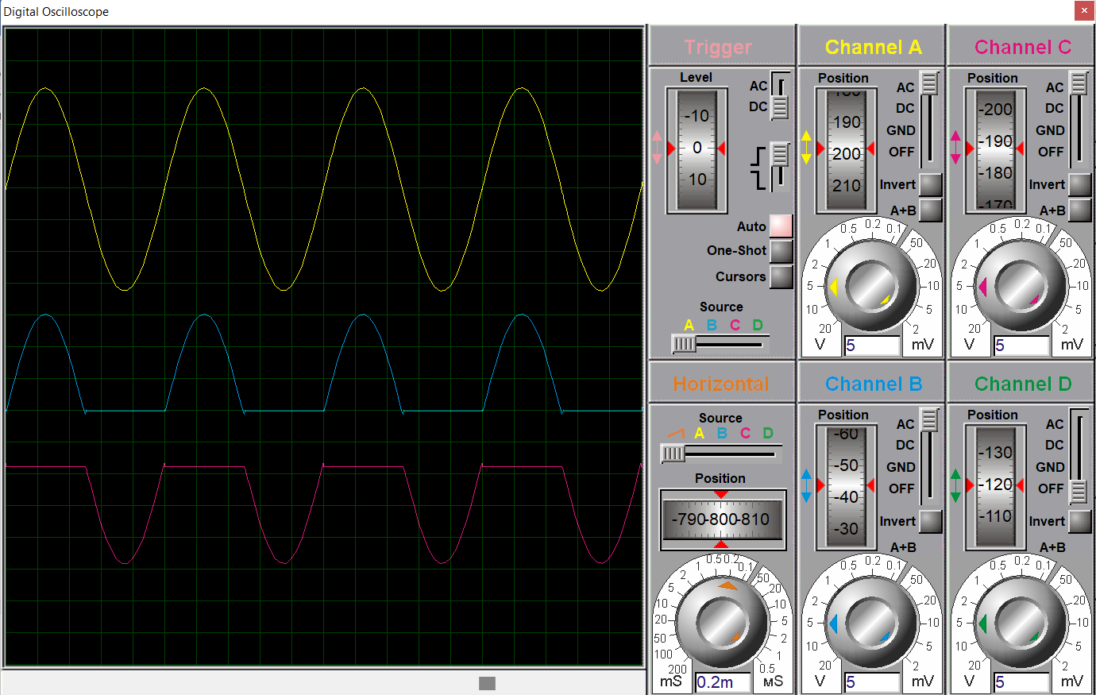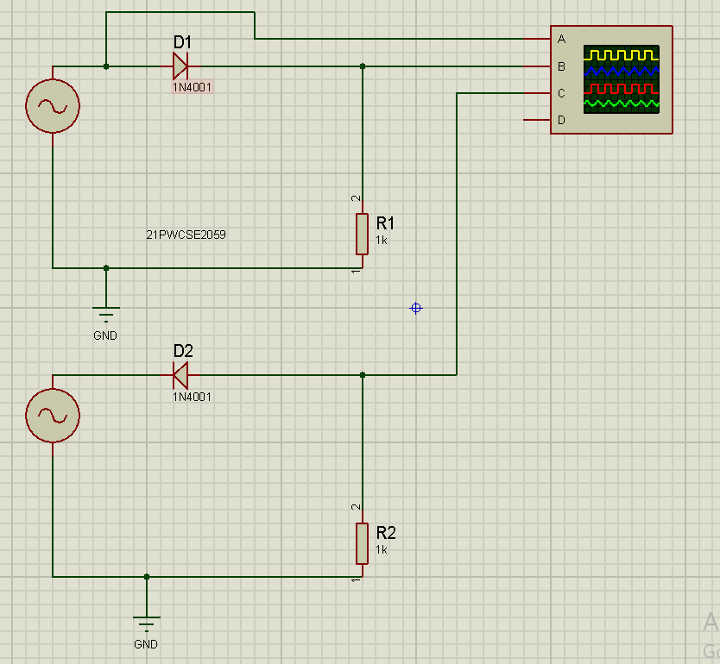**Unbiased Series Clipper Circuits:**

Figure 1-2: Output Waveform of Circuit Shown in Figure 1-1

Rectifier Circuit in Proteus

Figure 1-1: Schematic Diagram of Unbiased Series Clipper Circuits(Both Positive and Negative) in Proteus

Vsource = 30mV & Vo = 15 mV

**Biased Series Clipper Circuits:**

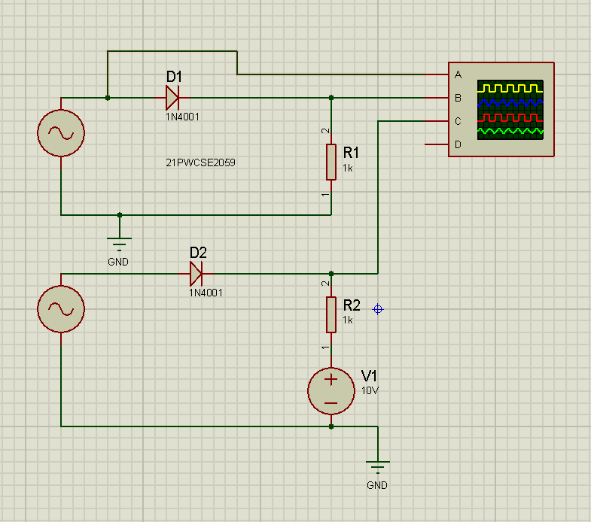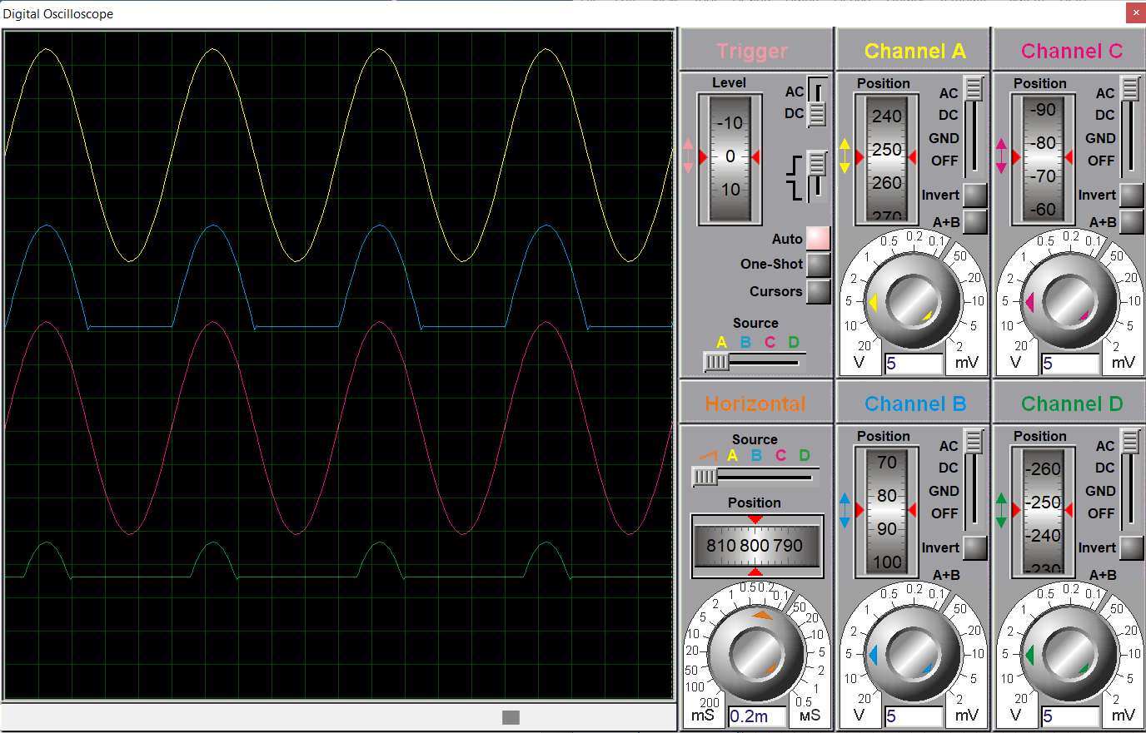

Figure 2-2: Output Waveform of Circuit Shown in Figure 2-1

Figure 2-1: Schematic Diagram of Unbiased and Biased Series Clipper Circuits in Proteus

Vsource = 30mV, Vo = 15 mV, VDC = 10mV & VClipped =15-10 = 5mV

**Part B: Series Clippers:**

* Construct the circuit in Fig.2. The input signal is an 8 V p-p square wave at frequency of 1000 Hz. Record the
* measured resistance value.
* Set the oscilloscope in DC mode.
* Put the oscilloscope probes at function generator and sketch the input waveform obtained.

**Observations:**

**Unbiased Parallel Clipper Circuits:**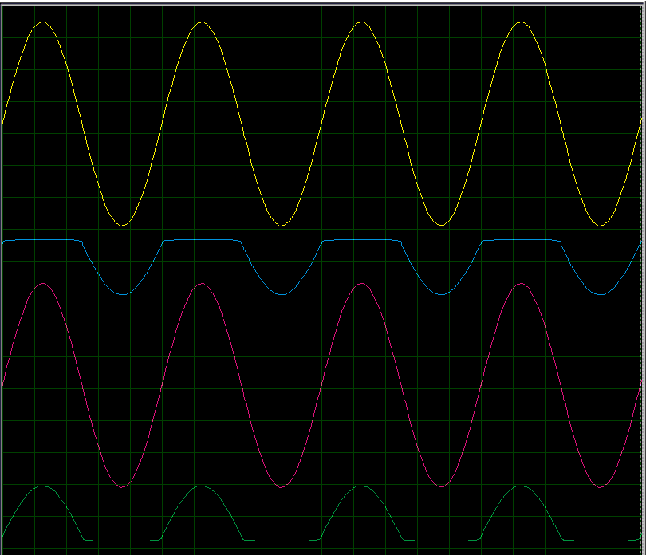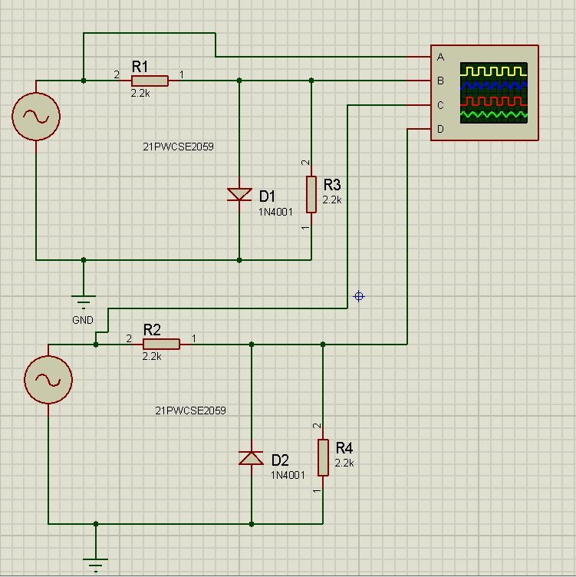

Figure 3-1: Figure 2-1: Schematic Diagram of Unbiased and Biased Series Clipper Circuits in Proteus

Figure 3-2: Output Waveform of Circuit Shown in Figure 3-1

Vsource = 32mV & Vo = 10 mV

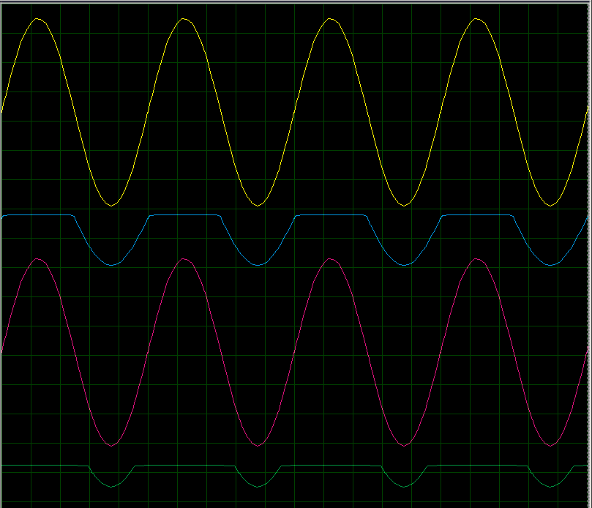**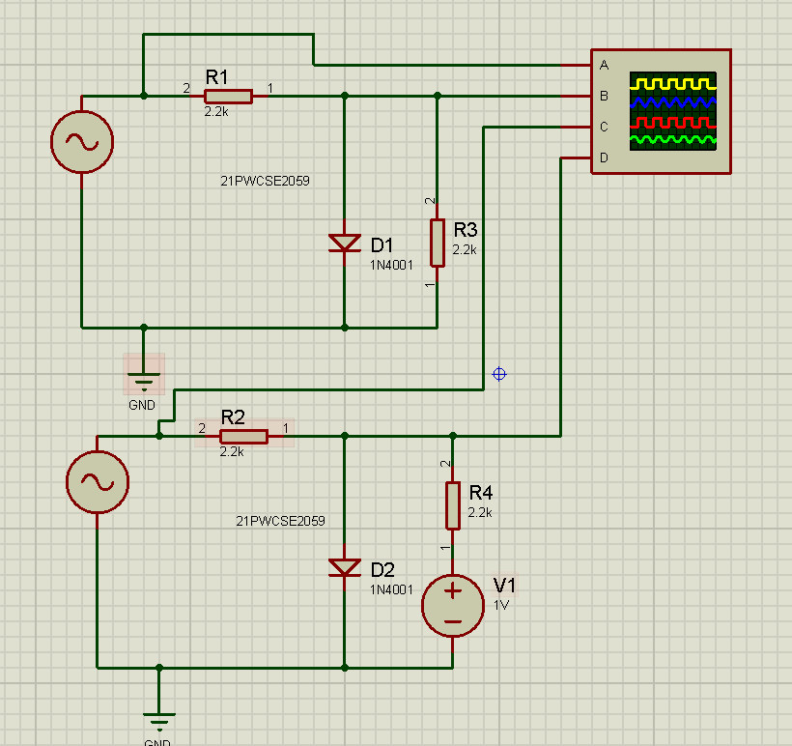Biased Parallel Clipper Circuits:**

Figure 4-1: Schematic Diagram of Unbiased and Biased Parallel Clipper Circuits in Proteus

Figure 4-2: Output Waveform of Circuit Shown in Figure 4-1

Vsource = 30mV, Vo = 9 mV & VClipped = 4mV

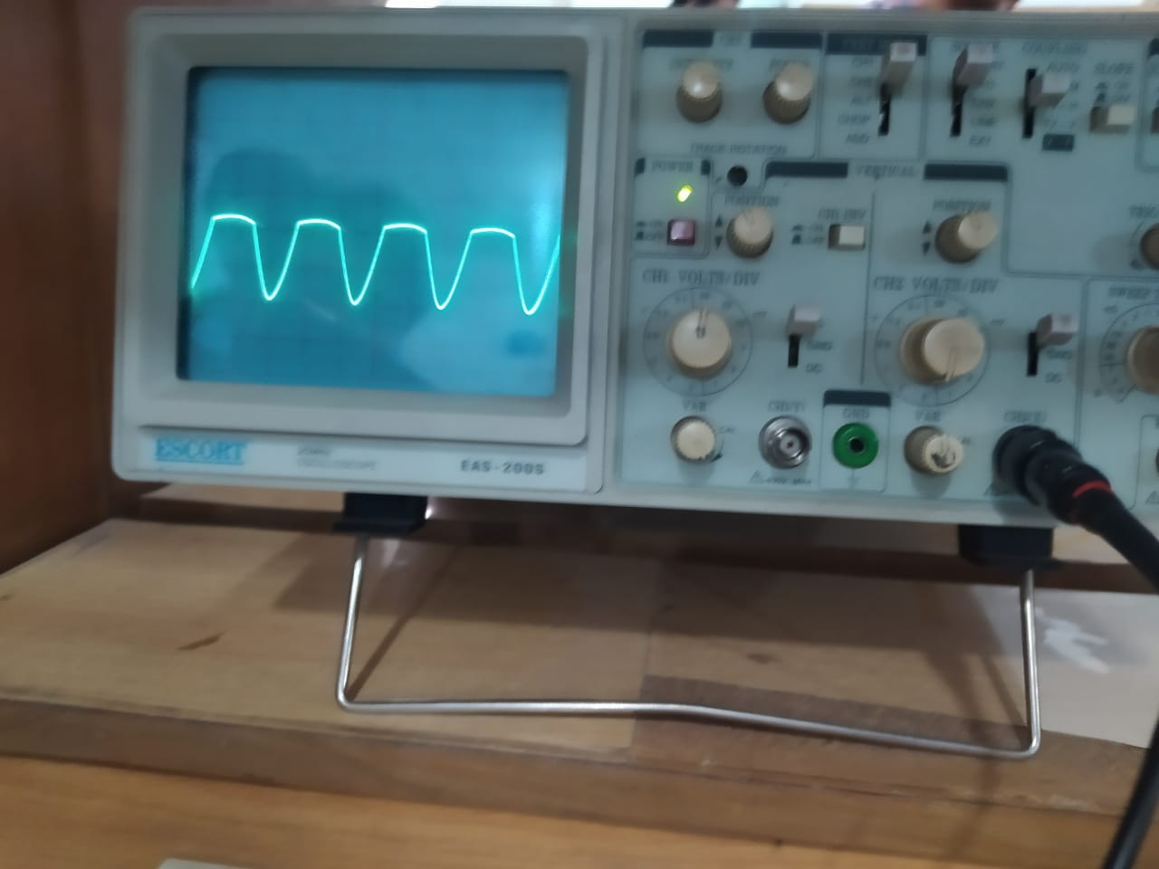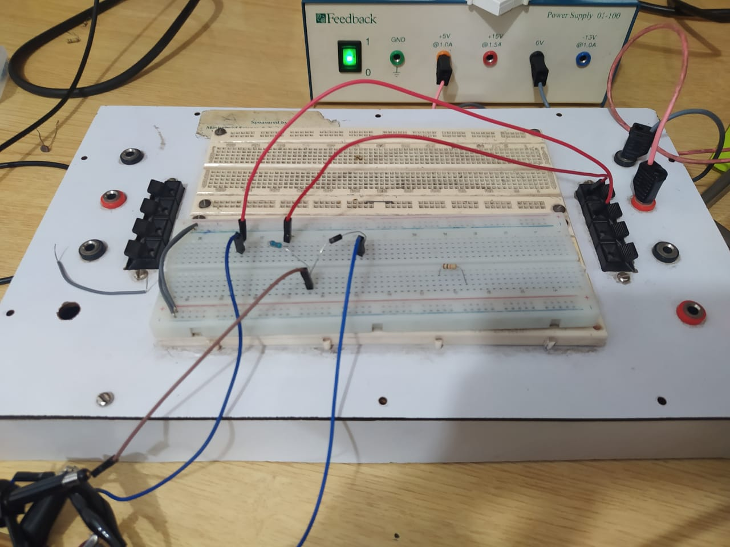**Practical Circuit Design in Lab:**

Figure 5-2: Positive parallel clipper without DC biasing

Figure 5-1: Positive parallel 5V DC biased clipper

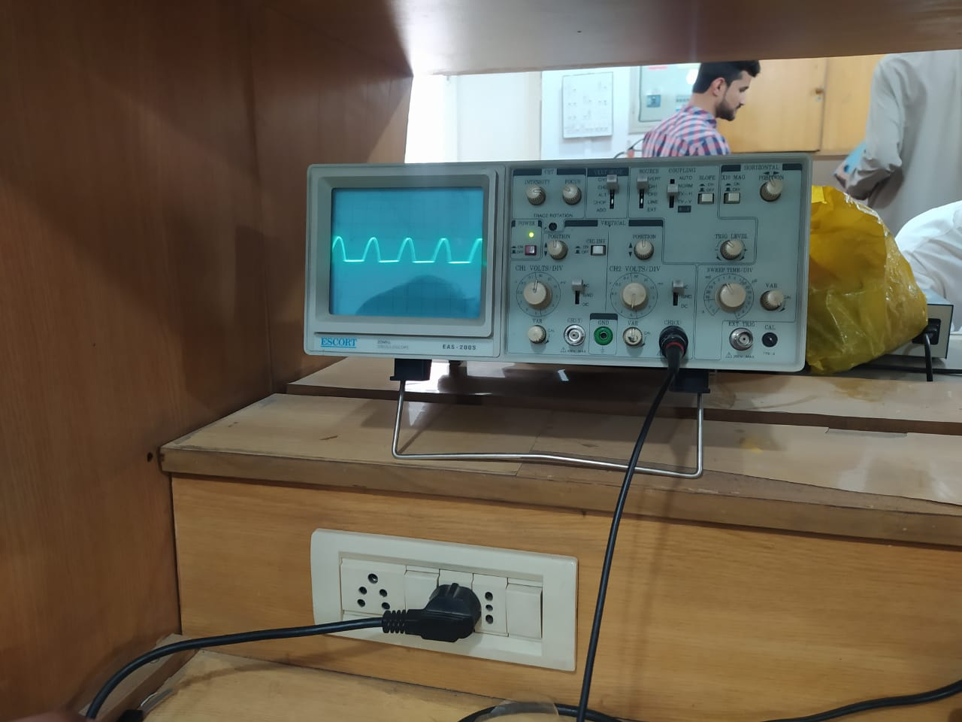

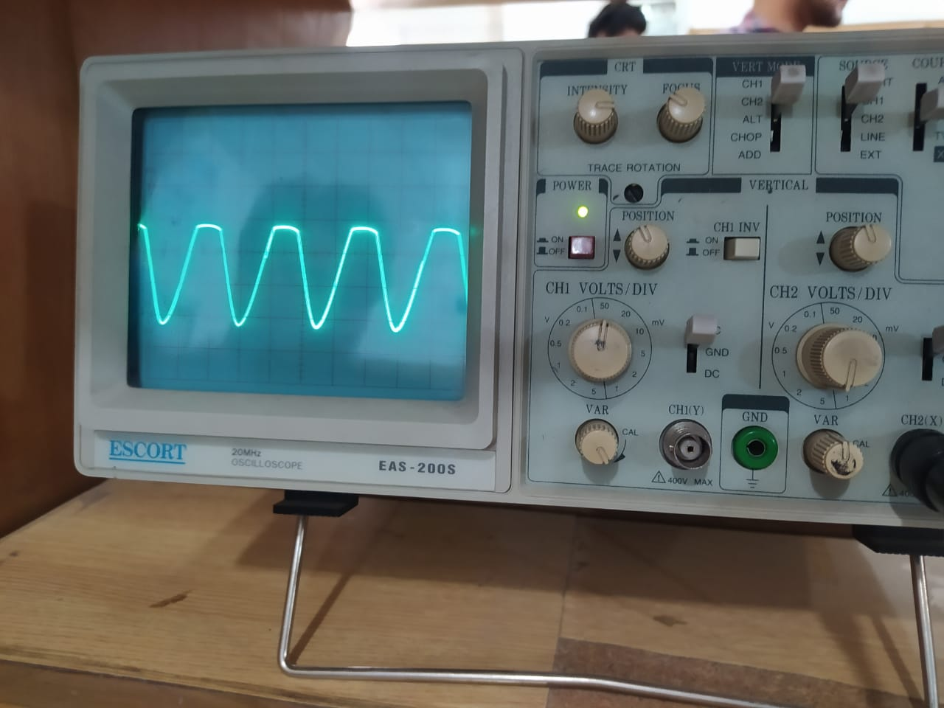

Figure 5-1: Negative clipper without DC biasing

Figure 5-3: Positive parallel 5V DC biased clipper

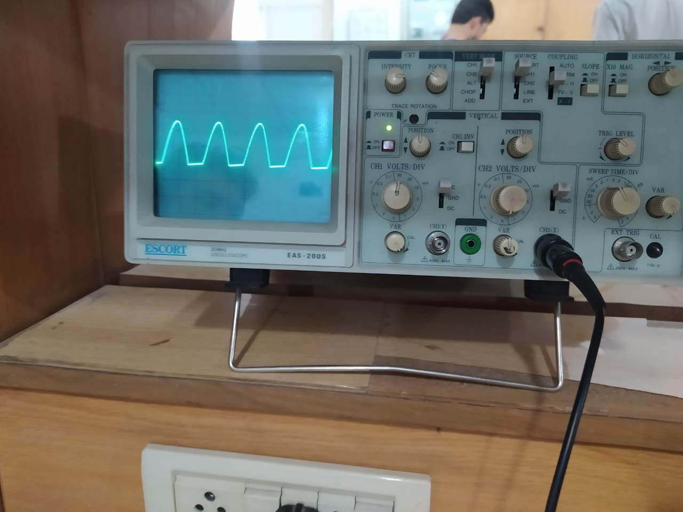

Figure 5-3: Negative clipper with 5 DC biasing